In this lab we are going to deploy the cart container that we deployed earlier to cloud run to GKE in autopilot mode.

1. Go to GCP and search for GKE and click Kubernetes engine  
   A screenshot of a computer

   AI-generated content may be incorrect.
2. Enable the API is asked
3. Go to clusters and click create  
   A screenshot of a computer

   AI-generated content may be incorrect.
4. Give cluster a name, your region and keep as Standard tier  
   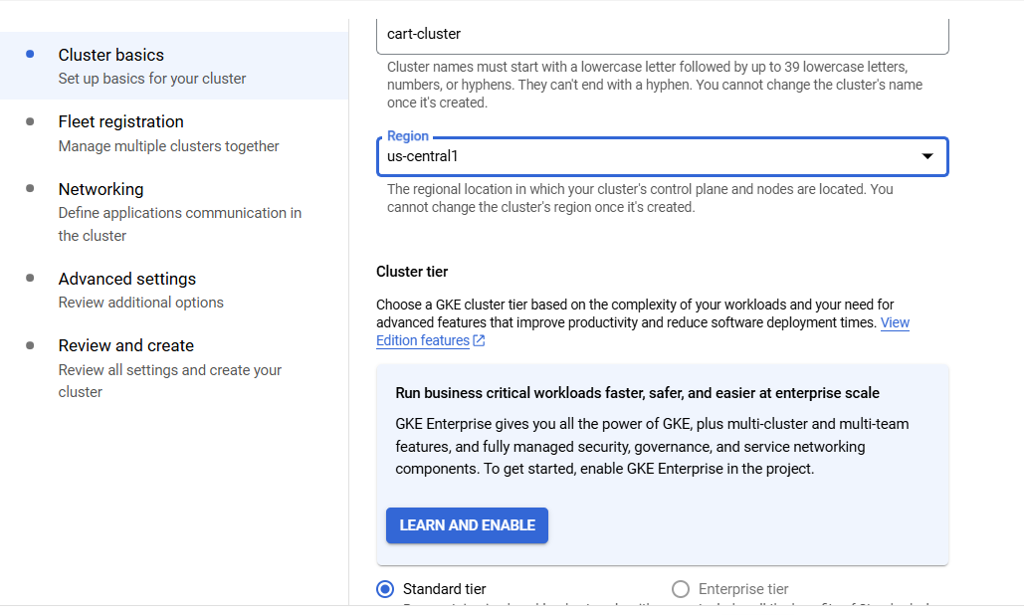
5. Go to next tab, fleet registration, keep all default
6. Go to next tab, Networking, check vpc details (keep default)
7. Go to Advanced settings tab, in this list we can see three options, Rapid, Ragular and Stable so basically what we set here is what is the Kubernetes version that we are going to use and how upgrades are going to be managed. Meaning when a new version of Kubernetes is released and this version has passed the validation of Google, then our cluster will be upgraded for this new version.

Rapid channel means that we are going to be upgraded as fast as possible to the new version, and stable channel is the slowest channel and only after we are really sure that we want to upgrade our cluster to the new version of Kubernetes, then the upgrade will take place

so we will stick to the regular channel  
  
keep all default and click create  
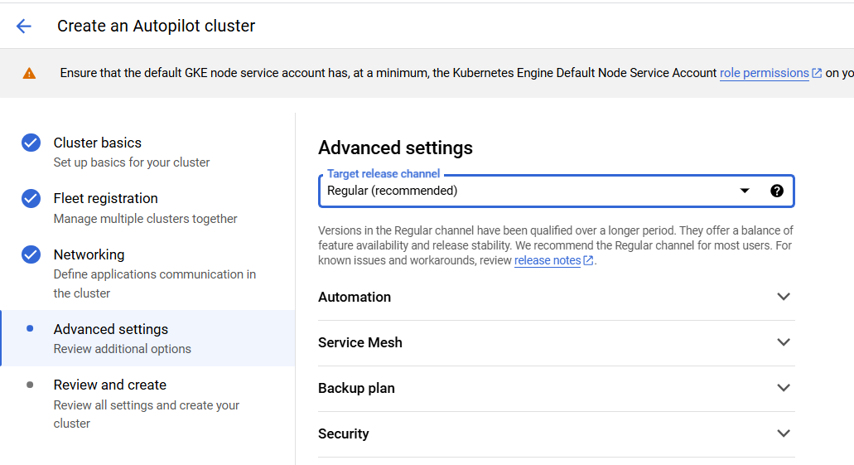

1. Once cluster is created which will take a few minutes, we will deploy our cart image to this cluster, for this go to work loads and click create deployment  
   A screenshot of a computer

   AI-generated content may be incorrect.
2. Give this deployment a name like cart and make sure the cluster which we just created is selected under Cluster option  
   A screenshot of a computer

   AI-generated content may be incorrect.
3. Select latest image from repo we created earlier via code  
   A screenshot of a computer

   AI-generated content may be incorrect.
4. In next option, check box to expose the deployment. By this we created a new public endpoint that allows us to access pods in cluster  
   here, service will be exposed to port 80, which is by default  
   and **target port** is the port at which pod   
   in **service type**, we have three options, first is cluster IP, by which only resources in the cloud can access this resource, second is Node port, which basically creates a service for each node and third is load balancer, which creates a load balancer with external IP  
   So here, we will select **load balancer** option  
   (Note, in case you see an error like does not have minimum availability,, ignore that and it will go away in few minutes)  
   A screenshot of a computer

   AI-generated content may be incorrect.
5. Once deployment completed, scroll down left pane and go to Gateways, services and Ingress option under networking. Here select your cluster, go to services and here it will show our cart service and type as external load balancer, which we selected while creting  
   A screenshot of a computer

   AI-generated content may be incorrect.
6. Click on the Ip address and this should open our cart webpage as per selected image  
   A screenshot of a computer

   AI-generated content may be incorrect.
7. Now go back to workloads tab again, open the cart deployment and scroll down, here we can see the pods, revision, exposed service details and all  
   A screenshot of a computer

   AI-generated content may be incorrect.
8. Now go to YAML option, and here we can see all the configurations related to this GKE deployment and if you scroll down, there we can see image details as well which is one of most important part  
   A screenshot of a computer

   AI-generated content may be incorrect.
9. Now go to vscode, gcp cloud option, expand Kubernetes and Add a cluster option. Select google cloud and then select cart-cluster  
   A screenshot of a computer

   AI-generated content may be incorrect.
10. This will add our Kubernetes cluster to the vscloud and from here we can check multiple options, like loadbalancer ip under services options and many more configurations  
    (If see error related to extension installation, close and launch vscode as administrator)  
    A screenshot of a computer program

    AI-generated content may be incorrect.